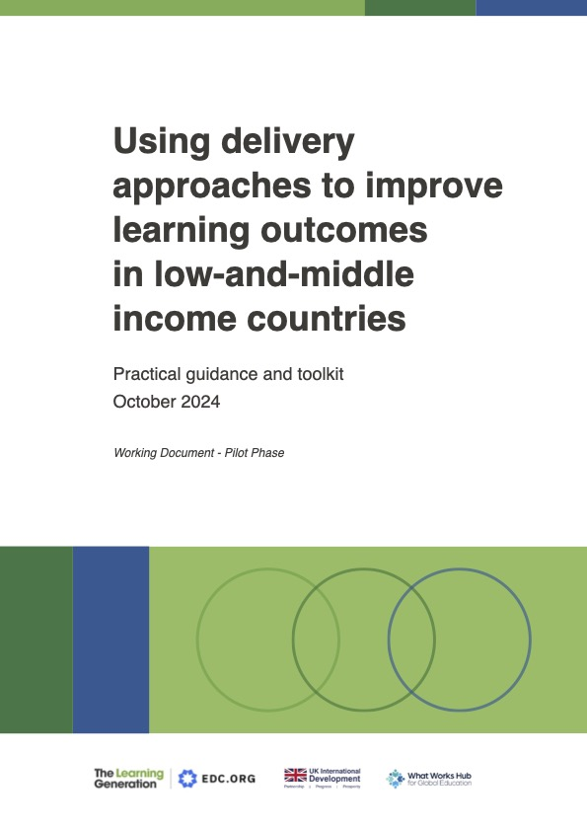

This checklist provides a practical framework to help you assess your system’s progress in designing, launching, implementing, and sustaining a delivery approach in your education system. The checklist should be used in conjunction with the delivery toolkit and aims to help you consider what is needed for an effective delivery approach. The first time the checklist is used, there may be many questions for which the answer is “in progress” or “no.” It is hoped that over time as progress is made, more answers may become “yes.”

**Stage 1: Design and Launch**

|  |  |  |  |
| --- | --- | --- | --- |
| **Leadership** | **Yes** | **In progress** | **No** |
| Do we have a political champion to spearhead the reforms and the delivery approach? |  |  |  |
| Is the political champion committed to improving education outcomes, and prepared to invest the time and level of effort required to drive accountability and address political challenges? |  |  |  |
| Is the political and bureaucratic leadership aligned on the high-level purpose and intended outcomes of the reforms? |  |  |  |
| Does the political champion have the required authority and influence to drive accountability and solve problems? |  |  |  |
| **Institutional setup and staffing** | **Yes** | **In progress** | **No** |
| Does the proposed leader of the delivery function have the credibility to drive system change? |  |  |  |
| Have we identified the expertise needed for implementing the delivery approach? Are we in the process of recruiting the right blend of skills? |  |  |  |
| Do we have the right balance between existing officials and external appointees? |  |  |  |
| Have we considered embedding delivery functions within existing bureaucratic structures? |  |  |  |
| Is the delivery function’s physical location close to key political sponsors and relevant staff and agencies working on education issues, or, if not, is there a plan to ensure close coordination? |  |  |  |
| **Stakeholder engagement** | **Yes** | **In progress** | **No** |
| Have we identified and engaged key influencers who can help guide our reforms to the education system? |  |  |  |
| Do we have a clear understanding of who the key actors in the delivery chain are? |  |  |  |
| Do we have a plan for how to engage organizations in the delivery chain? |  |  |  |
| Have we engaged directly with principals, teachers, and local education officials to understand their perspectives on challenges and root causes? |  |  |  |
| Do we have a communication plan to meaningfully engage principals, teachers, and local education officials in analysis, prioritization, delivery planning, and problem-solving? |  |  |  |
| **Analysis** | **Yes** | **In progress** | **No** |
| Do we have a strong understanding of the root causes of the challenges in our education system (e.g., from the ESP process, or through other analysis)? |  |  |  |
| Do we understand differences in access, participation, and outcomes among different groups of learners (e.g., differences driven by gender, location, wealth, and ethnicity)? Do we understand the factors behind these differences and how addressing them can drive change? |  |  |  |
| Do we understand the key strengths and weaknesses of our educational institutions, systems, and processes, giving us a foundation to build on? |  |  |  |
| Have we identified the key enablers and design factors that can be integrated into our improvement strategies? |  |  |  |
| **Focus areas and targets** | **Yes** | **In progress** | **No** |
| Have we selected a focused set of priority areas, based on our education system analysis, and supported by the best available evidence on “what works”? |  |  |  |
| Have we identified a clear set of SMART goals that will help us to achieve our vision? |  |  |  |
| **Delivery planning** | **Yes** | **In progress** | **No** |
| Have we identified the key evidence-based actions that will drive improvements in learning outcomes, including those for less advantaged learners? |  |  |  |
| Is the proposed plan realistic given the financial and human resources available? |  |  |  |
| Have we deprioritized (or stopped) activities that will not contribute to achieving targets? |  |  |  |
| Have we tested the feasibility of the actions and the proposed time frames? |  |  |  |
| Do government officials and delivery chain staff have the knowledge, skills, and motivation needed to lead and manage the changes required? |  |  |  |
| Do we have a strong understanding of the risks in the delivery chain? Are there plans in place to mitigate those risks? |  |  |  |
| Have we mapped out a clear trajectory allowing us to track progress and celebrate milestones as we move forward? |  |  |  |
| **Data infrastructure** | **Yes** | **In progress** | **No** |
| Do the existing data infrastructure and processes effectively support the data collection needed for monitoring of delivery? |  |  |  |
| Do we have the capability and resources to enhance and develop our data systems and processes? |  |  |  |
| **Communication** | **Yes** | **In progress** | **No** |
| Do we have a clear plan in place for frequent communication of goals and priorities to organizations in the delivery chain? |  |  |  |
| Do we have a clear plan in place for communication with the public and wider stakeholders about the reforms and their purpose? |  |  |  |
| **Plan for sustainability** | **Yes** | **In progress** | **No** |
| Have we developed a sustainability plan that identifies how we will maintain and sustain the key aspects of the delivery approach? |  |  |  |
| Are we actively monitoring progress in implementing the sustainability plan? |  |  |  |

**Stage 2: Learn**

|  |  |  |  |
| --- | --- | --- | --- |
| **Data collection and analysis** | **Yes** | **In progress** | **No** |
| Are the necessary mechanisms, including infrastructure and people, in place to collect high-frequency data to monitor the performance of departments, districts, and schools? |  |  |  |
| Do the data to be collected include measures of progress on learning? |  |  |  |
| Does the government have the analytical capacity to fully utilize the data by turning the data into actionable insights for impactful decision-making? |  |  |  |
| Are data analyzed by the government in a timely way, to inform decision-making processes? |  |  |  |
| Have mechanisms for gathering bottom-up feedback from frontline staff been developed and operationalized? |  |  |  |
| Are frontline and middle-tier managers given access to the  data, and do they have the capability, and incentives, to use the data locally? |  |  |  |
| **Routines and accountability** | **Yes** | **In progress** | **No** |
| Have regular routines been put in place to review progress, solve problems, and unblock bottlenecks in delivery? |  |  |  |
| Have competing lines of accountability been identified, reviewed, and simplified or removed? If they cannot be simplified or removed, are there plans in place covering how to work with multiple accountabilities? |  |  |  |
| Are the routines selected suitable for the changes we are trying to achieve? |  |  |  |
| **Learn and refine** | **Yes** | **In progress** | **No** |
| Are mechanisms in place to adapt the reforms based on insights from data, evidence, and problem-solving? |  |  |  |
| Are mechanisms in place to regularly review the performance of the delivery and accountability structures? |  |  |  |
| Are mechanisms in place to identify and mitigate any unexpected negative consequences caused by use of a delivery approach? |  |  |  |
| Have we explored opportunities to scale successful aspects of the changes we have made to the education system? |  |  |  |
| **Build capacity** | **Yes** | **In progress** | **No** |
| Do staff at the subnational level have a clear understanding of the goals, targets, and priorities that have been set, along with their roles, responsibilities, and accountabilities? |  |  |  |
| Have we identified any training needs or capacity gaps at the subnational level? Are there plans in place to meet these needs and further strengthen our teams? |  |  |  |
| Do system leaders, especially at the subnational and school levels, have the autonomy, powers, and authority required to deliver these reforms? |  |  |  |

**Stage 3: Sustain and Scale**

|  |  |  |  |  |
| --- | --- | --- | --- | --- |
| **Communicate progress and successes** | **Yes** | **In progress** | **No** | |
| Are we proactively sharing and celebrating evidence of improved learning outcomes, and other program successes to build momentum and support? |  |  |  | |
| **Culture change** | **Yes** | **In progress** | **No** | |
| Are ministry officials, middle-tier leaders, and school leaders fully committed to the key components of the delivery approach? |  |  |  | |
| Does the education system incentivize staff to focus on essential delivery behaviors, attitudes, and skills, through mechanisms such as performance management, pay, and promotion? |  |  |  |
| Have we explored creative ways to build bottom-up demand (e.g., from parents and other actors) for continual focus on learning outcomes? |  |  |  |
| **Embed** | **Yes** | **In progress** | **No** |
| Could any established parallel structures and mechanisms be integrated into pre-existing government processes, ensuring greater efficiency and sustainability? |  |  |  |
| Are external or temporary staff actively transferring their knowledge and skills to permanent officials, building long-term capacity within the organization? |  |  |  |
| Are we implementing measures to build lasting political, bureaucratic, and popular support to sustain delivery approaches amid political changes or the end of donor support? |  |  |  |
| Have we evaluated the impact of the interventions that have been implemented (and the delivery approach itself), to inform decisions on which interventions should be continued? |  |  |  |
| Do we have clear plans to smoothly transition any ongoing donor-funded interventions into the ministry’s operating budget, ensuring sustainability? |  |  |  |
| Have we identified potential sources of funding to support the continued success and sustainability of our interventions? |  |  |  |